PARISH OF ST. MICHAEL’S
PARISH PRIEST: Rev. Canon Bob Hamill

Charity No. 234092 21 Tilbury Road
Issue 739 East Ham
10th Feb. / 11th February 2024 London E6 6ED
For Private Circulation Only Tel: 07459 310 729
EMAIL: eastham@brcdt.org
Website: http://stmichaelse6.co.uk

Saturday First Mass of Sunday
10th 6.00 pm 7Mass Intentions (Josephine Worth)

Sunday SIXTH SUNDAY IN ORDINARY TIME (B)
11th 7.30 am Parish Family
9.00 am Thanksgiving (Jovita Ico)
11.00 am Miquela Edwards RIP (Rose Young)
4.00 pm Malayalam Mass

Monday
12th 8.45 am Morning Prayer
9.00 am Alice Drew Int. (Sue, John & Amie & Family)
9.40 am Rosary and Exposition of the Blessed Sacrament

Tuesday
13th 8.45 am Morning Prayer
9.00 am Emelita Gonzales RIP (Hawthorn Family)
9.40 am Rosary and Exposition of the Blessed Sacrament

Wednesday ASH WEDNESDAY-Ashes distributed at all Masses
14th 8.45 am Morning Prayer
9.00 am Patrick McLoughlin RIP
2.00pm Mass in St. John’s School –Tiffany Regis RIP (Maranan Family)
7.00 pm Parish Family

Thursday Thursday after AshWednesday
15th 8.45 am Morning Prayer
9.00 am Thanksgiving (Mayston Costa).

Friday Friday after Ash Wednesday
16th 8.45 am Morning Prayer
9.00 am Mgr. George Mooney RIP
9.40 am Stations of the Cross
6.30 pm Stations of the Cross
7.00pm Ann O’Connor RIP (John)

Saturday Saturday after Ash Wednesday
17th 11.00 am Exposition of the Blessed Sacrament and
Sacrament of Reconciliation.
11.45 am Mid-day Prayer, Benediction and Angelus
12.00noon Thanksgiving (Dioguinha Desouza)

Saturday First Mass of Sunday
17th 6.00 pm Monica Towns F.M

Sunday FIRST SUNDAY OF LENT (B)
18th 7.30 am Parish Family
9.00 am Nikhitha Gladson Int.
11.00 am Peter & Dora Pereira Anniv. (Lucy Pereira)
3.00pm Rite of Election –Brentwood Cathedral
4.00 pm Syro Malabar Mass

SIXTH SUNDAY IN ORDINARY TIME (B)
1st Reading Leviticus 13:1-2,44-46
Resp Psalm Psalm 31(32):1-2,5,11
R/You are my refuge, O Lord; you fill me with the joy of salvation
2nd Reading 1 Corinthians 10:31-11:1
Gospel Mark 1:40-45

Dear Parishioners,
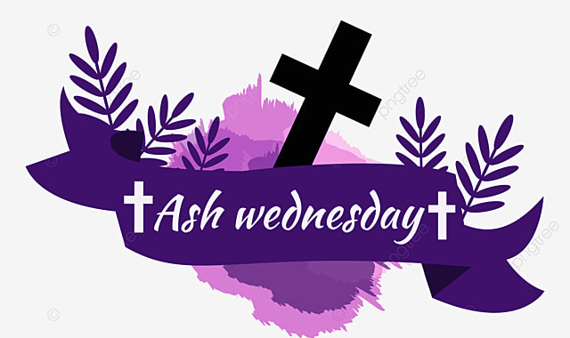

THE SEASON OF LENT: begins on Wednesday 14th February. It is an early start to the Season and we all need to prepare ourselves for this important time of the year. We ask ourselves what are we going to do during the Season of Lent. We will be having the Devotions, The Stations of the Cross each Friday at 6.30pm, followed by Holy Mass beginning on Friday 16th February. We do hope that as many of you can join us for these Masses. We should try and spend some time, each day Reading the Bible and praying the Rosary. Let us make this Season of Lent very special as we approach the Jubilee year of 2025.
YOUTH HALF TERM FUN AFTERNOON: For Half term this week our Youth Council are organsing and afternoon of games & Fun this Thursday.15th Feb. from 1pm to 4pm.Please bring comfortable clothes as we may be going to the park if the weather is good or we will use the School Hall. We will meet at Church 12.45pm, bring a snack and joke to share and a donation towards cost of Refreshments that will be provided. Speak to Leo or Johnny for more information. God Bless, Bob

ACTIVITIES THIS WEEK

Sunday World Day for the Sick, and Day of Prayer for the Unemployed.
11th Communion to the Sick/Housebound –1.30 pm

Monday Catholic Fellowship meeting Barkingside 11.00am
12th RCIA Course Continues, Church –7.30pm

Tuesday Funeral Mass Fr. John McKeon Holy Family Dagenham 11.30am
13th

Wednesday ASH WEDNESDAY
14th Mass in St. John’s School with Blessing of Ashes 2.00pm
Mass with distribution of Ashes 7.00pm
Thursday
15th Funeral of Kevin Kooner Bentley Cemetery 2.30pm

Friday
16th Stations of the Cross 6.30pm
Followed with Mass 7.00pm
Saturday
17th

Sunday Communion to the Sick/Housebound-3.00 pm
18th

COMING EVENTS

FHC Parents meet on Wednesday, 21 February
FHC children meet on Saturday 24 February
Funeral of Omobolanie Akuwudike, Friday 1st March

ANNUAL MISSIONARY APPEAL On the weekend of the 10th and 11th of February there will be the Annual Missionary Appeal. This year it will be given by the Missionary Sisters of St Peter Claver.
WALSINGHAM HOUSE: 40 years of Walsingham House Teams: 2024 marks 40 years of retreat teams at Walsingham House. There will be a celebration Mass with Bishop Alan on Saturday 31st August 2024 at Walsingham House at Abbotswick. Please save the date as it would be wonderful to see Walsingham House and BCYS alumni and friends gather together to mark this milestone. More information to follow in the New Year.
NEW ALTAR SERVERS 2024 There will be a registration and induction session for those wishing to join the altar serving ministry on Tuesday 13 February at 6:00pm. New Altar Servers need to have already received their First Holy Communion and be able to follow instructions and learn given tasks. Those aged under 18 years must be accompanied by their parent(s). Any prospective altar servers aged 18 years and older must also undertake the DBS process to receive a certificate that will allow them to work with children aged 17 years and younger. Servers who started in October do not need to attend this session.
VACANCY: Parish Administrator – St Joseph the Worker, Hutton
St Joseph the Worker, Hutton is looking for a Parish Administrator to provide complete and comprehensive administration for the church community. The candidate must have excellent written and verbal communication skills and be able to manage their own workload. The post is for 12 hours a week, over two days (one must be a Friday). The closing date is noon on
23rd February 2024.
MARRIAGE: All couples wishing to celebrate the Sacrament of Marriage must contact the Parish Priest at least six months before the anticipated wedding date, to ensure all the paperwork is sufficiently filled in.
DIOCESAN PILGRIMAGE 2024: Join Bishop Alan on the Diocesan
Pilgrimage to Lourdes (Friday 19 – Friday 26 July). To book, please go
online: Brentwood Lourdes - Lourdes - Tangney Tours (Tangney-
tours.com). If you wish to discuss any aspect of the pilgrimage, please e-
mail Kathryn Young or Suzanna Reeves at Lourdes@brcdt.org
TELEPHONE LINE PROBLEMS Just to remind you that the Parish mobile number still in use is 07459 310 729 and we can receive emails at eastham@brcdt.org Once again we thank you for your understanding and patience and we very much regret the inconvenience all this is causing

