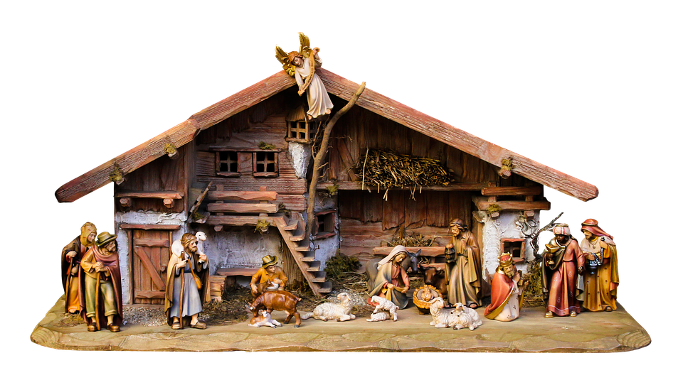
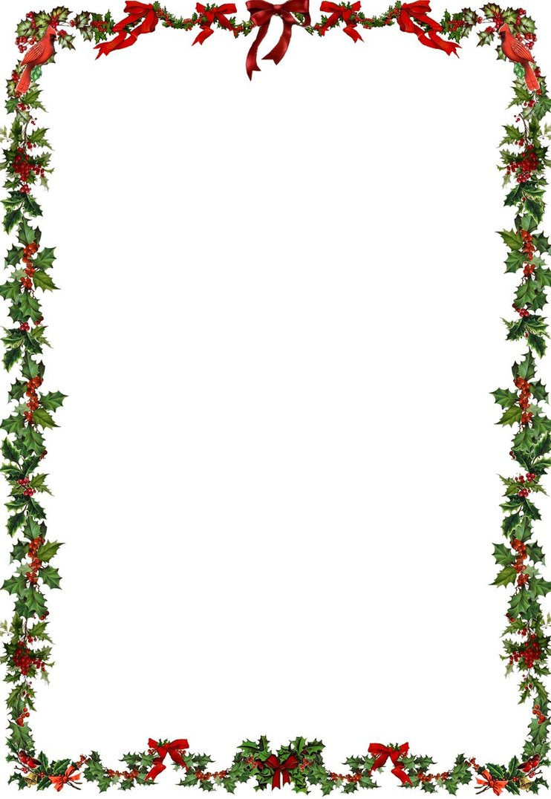

CHRISTMAS MASSES:
The First Mass of Christmas is as follows: Christmas Eve,
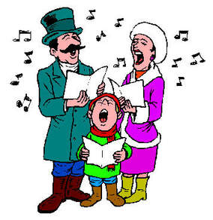
Tuesday 24th December at 6.00pm
(The Family Mass)
Office of Readings at 11.30pm,
Midnight Mass.
Christmas Morning
Masses will be 8.00am; 9.00am; 11.00am
Christmas Evening Mass will be at 6.00pm

